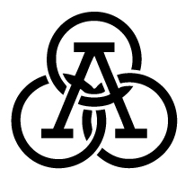

**Kindergarten Poetry Recitation #1**

Poem recitations are a tradition at Athlos. Each grading period your child will recite a poem. For the first grading period, each student will be reciting *The Pledge of Allegiance*. Your child will be required to memorize and recite their poem in front of the class on an assigned day. **Poetry Recitation #1 is on: Wednesday 9/5-Friday, 9/7.** This poem will be graded on the following criteria:

1. Posture:
   * Places right hand over heart.
   * Stands at attention toward the flag.
2. Accuracy:
   * Recites words fluently.
   * Recites all the words in the poem.
3. Audience Perception:
   * Uses emotional appeal through voice inflection.
   * Demonstrates respect toward flag.
4. Voice:
   * Speaks loudly
   * Clearly annunciates words

Parents are invited to attend Poem Recitations on their child’s assigned day. A schedule will be sent home the week before Poem Recitations.



***The Pledge of Allegiance***



I pledge allegiance to the flag

Of the United States of America,

And to the republic for which it stands,

One nation under God, indivisible,

With liberty and justice for all.